[2023 지자체와 함께하는 한국유학박람회 개최 안내]

교육부 국립국제교육원에서는 『2023 지자체와 함께하는 한국유학박람회』를 아래와 같이 개최합니다.
1. 행사명: 2023 지자체와 함께하는 한국유학박람회(상반기)
2. 일자: 2023.6.27.(화) ~ 7.6.(목) <10일>
3. 주요메뉴소개
o 한국유학안내, 장학금제도, 대학정보, 온라인 입학신청, 온라인 상담, 채팅상담 등
4. 참가대학: 65개교
5. 접속 및 참가방법
O 한국유학종합시스템 웹사이트(www.studyinkorea.go.kr)에 접속하여 박람회 링크선택
O 등록(Registration) 후 박람회 기간 중 사이트방문

[Study in Korea Education Fair with Local Governments 2023]
It is our pleasure to announce that NIIED will hold “2023 Study in Korea Online Education Fair(the First half)” for international students.
- Name of the event: 2023 Study in Korea Online Education Fair(The First half)
- Date: Jun 27th (Tue) ~ Jul 6th (Thu)
3. Introduction of main contents
- Studying in Korea, scholarship programs, information about Korean Universities, online application, online consultation, Live Chat
4. Participating universities: 65 universities
5. How to access and join the online education fair (Please see the attachment.)
- Visit the Study in Korea website (www.studyinkorea.go.kr) to select the online education fair link.
- Complete the registration and visit the website during the online education fair.

<Attachment>
How to register“2023 Study in Korea Education Fair with Local Governments”
- Visit the Study in Korea website“www.studyinkorea.go.kr”
- Click “2023 Study in Korea Online Education Fair with Local Governments”
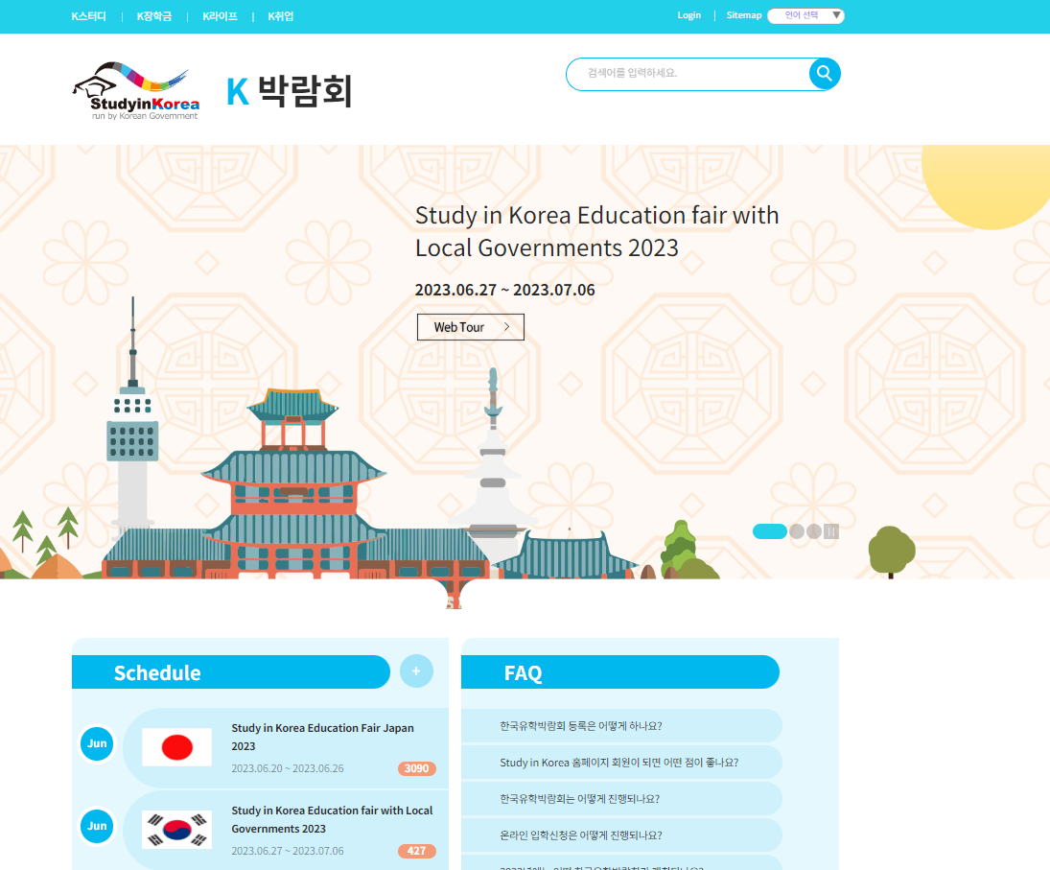

- Click “Registration” to join the Fair.
- Please visit the education fair page during the period of Jun 27th (Tue) ~ Jul 6th (Thu).

